|  |
| --- |
|  |
| **FPT UNIVERSITY**  Capstone Project Document  ---------------------- |

**IVOLUNTEER**

Report #1 – Project Introduction

|  |  |  |
| --- | --- | --- |
| **iVolunteer** | | |
| **Group Members** | Nguyễn Minh Đức | SE03053 |
| Nguyễn Thạc Sơn | SE03343 |
| Nguyễn Văn Tâm | SE02495 |
| Võ Tôn Phúc | SE03162 |
| Phạm Văn Trọng | SE03292 |
| **Supervisor** | Mr. Bùi Đình Chiến | |
| **Project code** | ISVN | |

**- Hanoi, 05/2016 –**

# SIGNATURE PAGE

|  |  |  |
| --- | --- | --- |
| AUTHOR: | Võ Tôn Phúc  Team Member  Phạm Văn Trọng  Team Member | 15/05/2016 |
| REVIEWERS: | Nguyễn Minh Đức  Project manager | --/--/2016 |
| APPROVAL: | Bùi Đình Chiến | --/--/2016 |

Record of change

*A - Added M - Modified D – Deleted

|  |  |  |  |  |  |
| --- | --- | --- | --- | --- | --- |
| Effective Date | Changed Item | A,M,D | Change Description | Reason for Change | Rev. Number |
| 15/May/2016 | Create Introduction | A | Create Introduction | First version | 1.0 |
|  |  |  |  |  |  |
|  |  |  |  |  |  |
|  |  |  |  |  |  |
|  |  |  |  |  |  |
|  |  |  |  |  |  |
|  |  |  |  |  |  |
|  |  |  |  |  |  |
|  |  |  |  |  |  |
|  |  |  |  |  |  |
|  |  |  |  |  |  |
|  |  |  |  |  |  |
|  |  |  |  |  |  |
|  |  |  |  |  |  |
|  |  |  |  |  |  |
|  |  |  |  |  |  |
|  |  |  |  |  |  |
|  |  |  |  |  |  |

Table of Contents

SIGNATURE PAGE 1

1 INTRODUCTION 3

1.1 Purpose 3

1.2 Acronyms and Definitions 3

1.3 Project Information 3

2 THE PEOPLE 3

2.1 Supervisors 3

2.2 Team members 4

3 RAISE PROBLEM AND THE IDEA 4

4 LITERATURE REVIEW 5

4.1 WHH – Worldwide Helpers 5

4.2 Facebook 6

4.3 Volunteerforeducation (V.E.O) 6

5 PROPOSAL 7

5.1 Objectives 7

5.2 System features 8

6 BENEFIT FROM PROJECT 8

6.1 For our group 8

6.2 For Community 8

7 CRITICAL ASSUMPTION AND CONSTRAINTS 8

7.1 Critical assumption 8

7.2 Constraints: 8

8 POTENTIAL RISKS 9

9 REFERENCES 9

# INTRODUCTION

## Purpose

This document is created to introduce about our team, raise problem and initial idea of the Capstone project in FPT University. In this document we also present overviews of some similar existing solution, a brief description about our expected system and some potential risks, critical assumptions, constrains. It provides information about what our project can do.

## Acronyms and Definitions

|  |  |
| --- | --- |
| **Acronym & Abbreviation** | **Definition** |
| ISVN | iVolunteer Social Network |
| WHH | Worldwide Helpers |
| V.E.O | Volunteerforeducation |
|  |  |
|  |  |

*Table 1-1: Definitions and Acronyms*

## Project Information

* Project name:
  + Vietnamese: **Tôi Tình Nguyện**.
  + English: **iVolunteer**.
* Project code: **ISVN**.
* Project group name: **iVolunteer**.
* Product type: **Website application – Social Network**.
* Timeline: **From May 9th 2016 to August 27th 2016**.

# THE PEOPLE

## Supervisors

|  |  |  |  |  |
| --- | --- | --- | --- | --- |
|  | **Full name** | **Phone** | **E-mail** | **Title** |
| Supervisor | Bùi Đình Chiến | 0904232472 | [ChienBD@fpt.edu.vn](mailto:ChienBD@fpt.edu.vn) | Lecturer |

*Table 2-1: Supervisor’s information*

## Team members

|  |  |  |  |  |  |
| --- | --- | --- | --- | --- | --- |
|  | **Full name** | **Student code** | **Phone** | **E-mail** | **Role in Group** |
| 1 | Nguyễn Minh Đức | SE03053 | 0163 320 6056 | [DucNMSE03053@fpt.edu.vn](mailto:DucNMSE03053@fpt.edu.vn) | Leader |
| 2 | Võ Tôn Phúc | SE03162 | 0168 640 3194 | [PhucVTSE03162@fpt.edu.vn](mailto:PhucVTSE03162@fpt.edu.vn) | Member |
| 3 | Nguyễn Văn Tâm | SE02495 | 0163 895 9769 | [TamNVSE02495@fpt.edu.vn](mailto:TamNVSE02495@fpt.edu.vn) | Member |
| 4 | Nguyễn Thạc Sơn | SE03343 | 098 884 8212 | [SonNTSE03343@fpt.edu.vn](mailto:SonNTSE03343@fpt.edu.vn) | Member |
| 5 | Phạm Văn Trọng | SE03292 | 0163 365 3835 | [TrongPVSE03292@fpt.edu.vn](mailto:TrongPVSE03292@fpt.edu.vn) | Member |

*Table 2-2: Tem member’s information*

# RAISE PROBLEM AND THE IDEA

Nowadays, Volunteering has been expanding in many countries in the world. Volunteering gives us an opportunity to change people’s lives, including our own. It gives us the satisfaction of playing a role in someone else’s life, helping people who may not be able to help themselves. Volunteering is a way of giving back to our community while developing important social skills, and gaining valuable work experience all at the same time. Despite all those matters, the recent volunteering has revealed some limitations: the communication of the events, coordinating the activities, have yet to publicize and expand/extent the platforms or mentioning/commending individuals who have contributed/devoted for volunteering…

Moreover, with the recent emergence of social networks, people tend to share sharing their experiences, their emotions about volunteering to their friend, or seek for local friends on social sites such as Facebook, Twitter… However, these kind of social network sites focus more on sharing general information or experiences than specific information about volunteer information or experiences. Because it has no limitation about contents, user can post everything they want. Assume that you will use Facebook to post or share volunteer activities, experience. It easily to realize that it difficult to manage these information, these post with other things on Facebook. After the volunteer activity, you may want to look for the post and the pictures from a specific place. This would be an unpleasant experience when you have to scroll through your entire wall which is full of unrelated posts just to find some pictures or some comments.

Consequently, we want to create a social network call by “iVolunteer” to help the volunteer and organization which joining in volunteer activities connect with other. They can launch their volunteer project or join other volunteer project that they want.

# LITERATURE REVIEW

## WHH – Worldwide Helpers

<http://www.worldwidehelpers.org/>

Worldwide Helpers is a non-profit social networking site created to foster partnerships between volunteers and charitable organizations worldwide. It commits itself to removing the financial barriers of volunteering by providing only low/no cost projects. It raises awareness of organizations whilst at the same time providing them with the manpower and knowledge they need to survive.

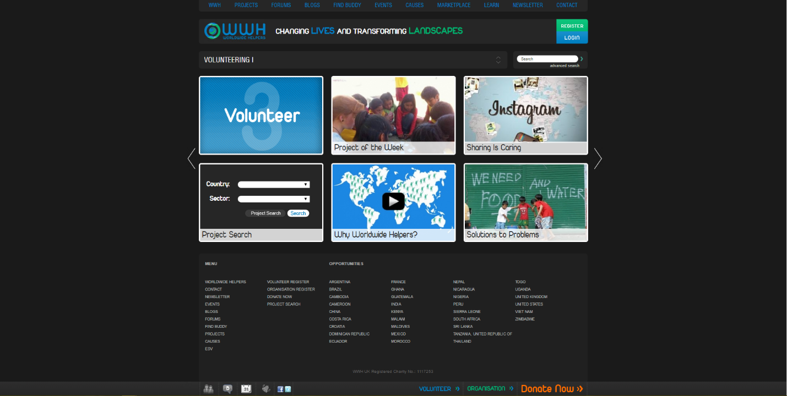

*Figure 4-1: Worldwide Helpers ‘s Homepage*

Worldwide Helpers offers organizations the opportunity to be a part of a unique community of volunteers across the world! Create profiles, post projects and promote events which will be instantly visible to hundreds of thousands of individuals worldwide who are keen to help. Search for volunteers who have the skills you specifically require for a certain project. WWH provides you a platform to raise awareness of your cause while allowing you to be proactive in making change happen for yourself. WHH provides a lot of types to communicate between volunteer like Forum, Blogs, Event, Market places… support project in worldwide, that make WHH have lot of volunteer in worldwide join this network. And this is a completely free service.

However, the community of WHH discuss in a traditional forum – without personal media galleries, likes, shares and other things a social site can offer. These force, WHH just provide project information only, there are not provide workplace for project. It does not have donate system for each project, and current donate system use PayPal or Euro money only, it’s quite difficult for user who do not have PayPal or do not use Euro money.

## Facebook

<http://www.facebook.com/>

Facebook helps you connect and share with the people in your life. In Facebook, user can post or share everything with no limitation about fields or domains. Facebook have community with a lot of user, and support group, fan page, easily to communicate in each project.

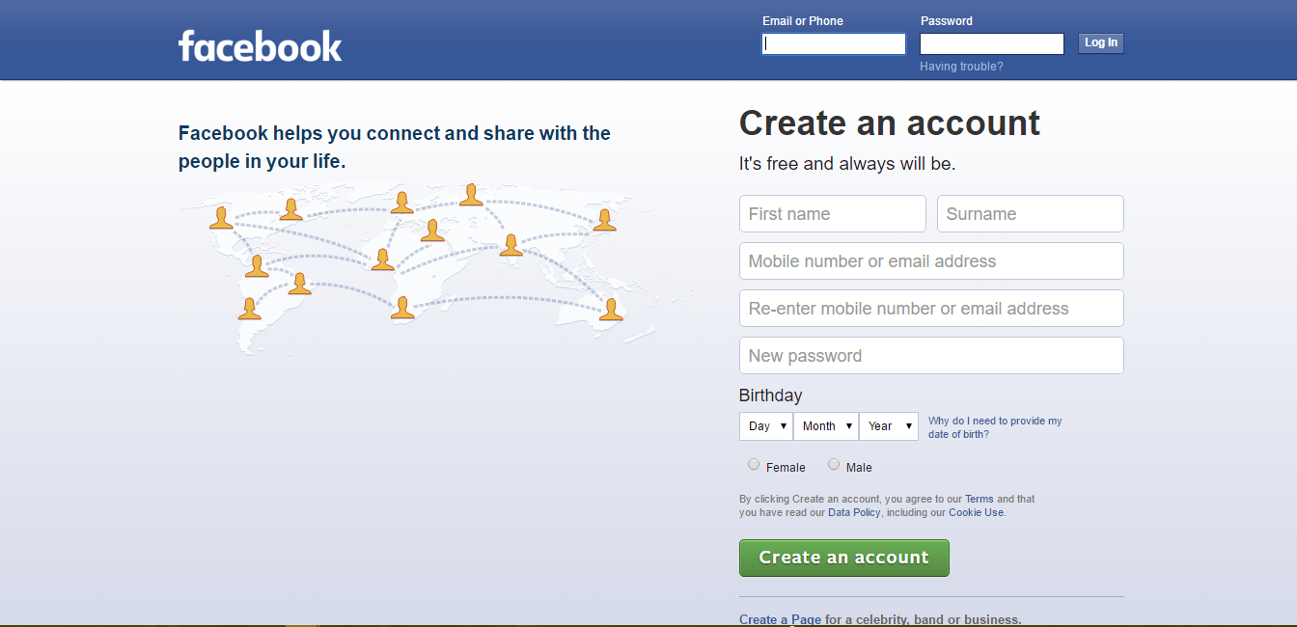

*Figure 4-2: Facebook’s first page – Login Page*

On the other hand, as we mentioned in raise problem and the idea, posts you created about volunteer activities information would likely get lost in a sea of other irrelevant posts. Moreover, if you have joined a lot of volunteer activities it same that you have to create a lot of posts, it would be painful to collect every single post related to your activities from your Facebook wall. It easily to realize that it difficult to manage these information, these post with other things on Facebook. After the volunteer activity, you may want to look for the post and the pictures from a specific place. This would be an unpleasant experience when you have to scroll through your entire wall which is full of unrelated posts like a thousand of post just to find some pictures or some comments.

In Facebook, people only can see all information if they have Facebook account already. It will narrow the people who want to join public volunteer activities or the people who want to donate for a project while they do not have account yet.

## Volunteerforeducation (V.E.O)

<http://volunteerforeducation.org/>

V.E.O are the community network connecting people who want to give hands of help in volunteering for education to improve the living standard of local people. V.E.O identify the needs and offer placements for volunteers to join network and contribute their time to support local communities

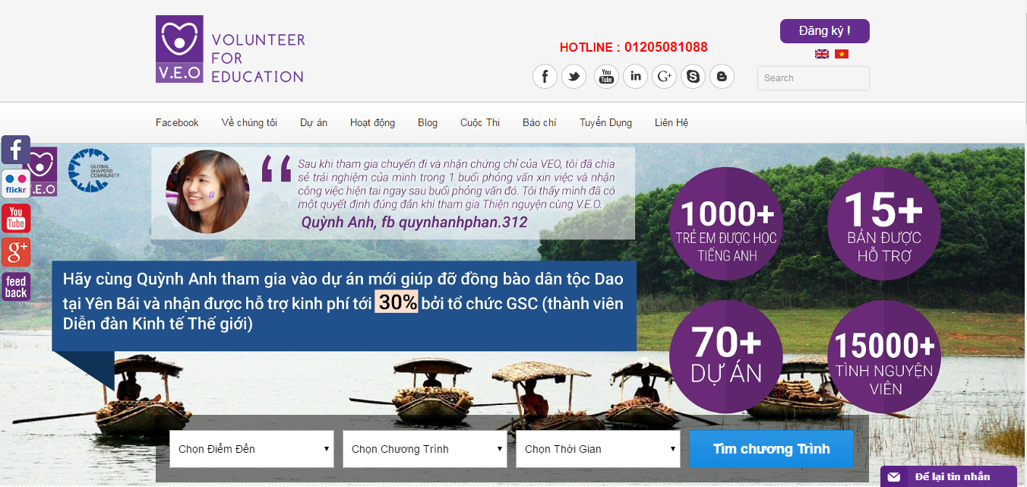

*Figure 4-3: V.E.O Homepage*

For project, V.E.O selected poor, disadvantaged and disabled people in local, ethnic communities in Vietnam and posted to the homepage. The volunteers can easy to search volunteer projects by choosing follow 3 categories such as destination, type, duration. The project will provide full information, requirements, duration of the project and the volunteers will register. Then, the volunteer can share via social networks as Facebook, Twitter, Google Plus. Moreover, V.E.O organize volunteer work camps which have voluntary activities, leisure activities. V.E.O provide functions as contact, send message, feedback to communicate with V.E.O.

Although V.E.O are the community network connecting people but It don’t have place for the volunteer discuss or talk with each other or share image .If the volunteers want to do it, must be used “volunteer for education” page on Facebook .The volunteers don’t know the information and how to donate for the project. With Send Message, the volunteer takes a long time to admin to respond.

# PROPOSAL

## Objectives

Our objective is building a web application that create a platform to help people who have abilities and interested in volunteer activities. We expect that when this project complete, it will be a place for volunteer in the whole country gathering, communicating or sharing their experience, their emotion about volunteering. A place can run volunteer project in all domain. A place supports all activities of volunteering such as: finding volunteers, calling for donate, contribution, communication on project… It helps volunteer activity become simple and more efficient.

## System features

# BENEFIT FROM PROJECT

## For our group

After developing and implementing this project, our group can gain:

* More experiences of software project management.
* More knowledge and skills about ASP .NET MVC 5 and programing.
* How to teamwork in project, communicate with team members.
* More knowledge about new technologies and methods.

## For Community

Because this project is Volunteer Social Network so the main factor that we support mainly is Volunteer and people who interested in volunteer activities. When they join our network, they will get:

* Friendly interfaces.
* Easy to gathering, communicating or sharing their experience, their emotion about volunteering with other volunteer through like/love, comment system of Social Network
* Easy to join or create own volunteer project.
* Easy to manage own volunteer group, volunteer organization, own project
* Easy to run volunteer activity like finding volunteers, calling for donate, contribution, communication on project…

# CRITICAL ASSUMPTION AND CONSTRAINTS

## Critical assumption

* Training: Training about new technologies and method for all developer, test process, test model for all tester, how to use tool for all member on maximum time is 3 weeks. On training process, all member also completes all task on time.
* Human resources: Assume that all members in team have a good healthy to do their tasks.
* Project scope will not be modified.

## Constraints:

* Time and deadline: We must complete task on time. We have 14 weeks to complete our project, but we estimate that we will done all work on 12 weeks and spend 2 more weeks to be back up time and review all things that we will have done. Each member works 5 hours/day and 5 days/week. Besides, we have to submit report documents before deadline to supervisor can review.
* Quality: Our project must be run well in Google Chrome 40 and Firefox 30 or higher.
* Process: We have to follow the software processing of ….
* Human resources: There are 5 members in our team, 4 member have to study 2 subjects in 3 subjects (Japanese, JIT and JFE) at school.

# POTENTIAL RISKS

When we are doing capstone project, we can get some risks as describe below:

* Under-estimate scope and time or miss deadline because lack of experience in group working, managing and controlling work.
* Loss data, source code before uploading data to server because of careless.
* Laptop is broken because of careless or accident.
* Human resources: Team member cannot complete their works because of personal reasons: health, family…, key member leave team or un-cooperating on team.
* Change requirements: Requirement changed when some functions cannot be completed or some technologies is not suitable.

# REFERENCES

* Worldwide Helpers: <http://www.worldwidehelpers.org/>
* Facebook: <http://www.facebook.com/>
* Volunteerforeducation (V.E.O): <http://volunteerforeducation.org/>